Lab 4

P1: Write a program to convert 4-digit BCD number to HEXADECIMAL number and store the result in memory.

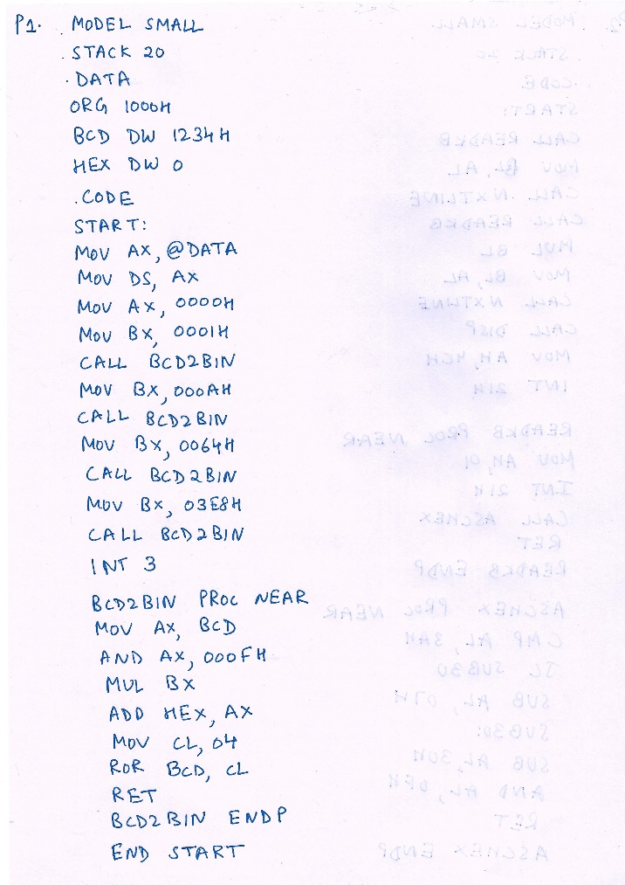

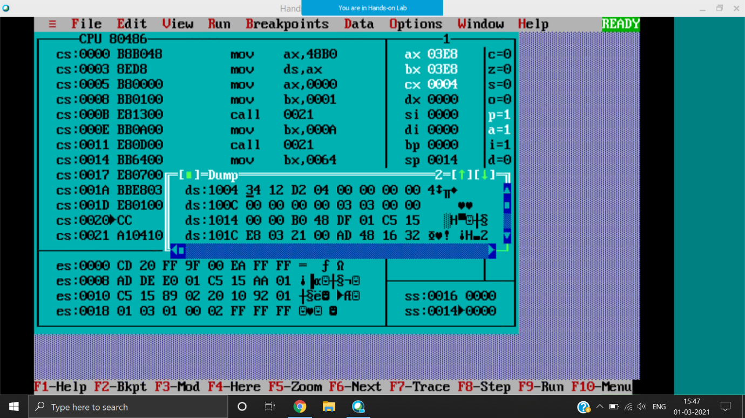

DS: 1004H

Output at 1006H, 1234 in hexadecimal is 4D2

P2: Write a program to input two single-digit hex numbers from keyboard and display their product on the screen.

|  |  |
| --- | --- |
|  |  |
|  | N1 = F ie (15)10  N2=3  N1*N2 = 2D ie (45)10 |

P3: Write a program to convert the given HEXADECIMAL digit to ASCII byte and store the result in memory.

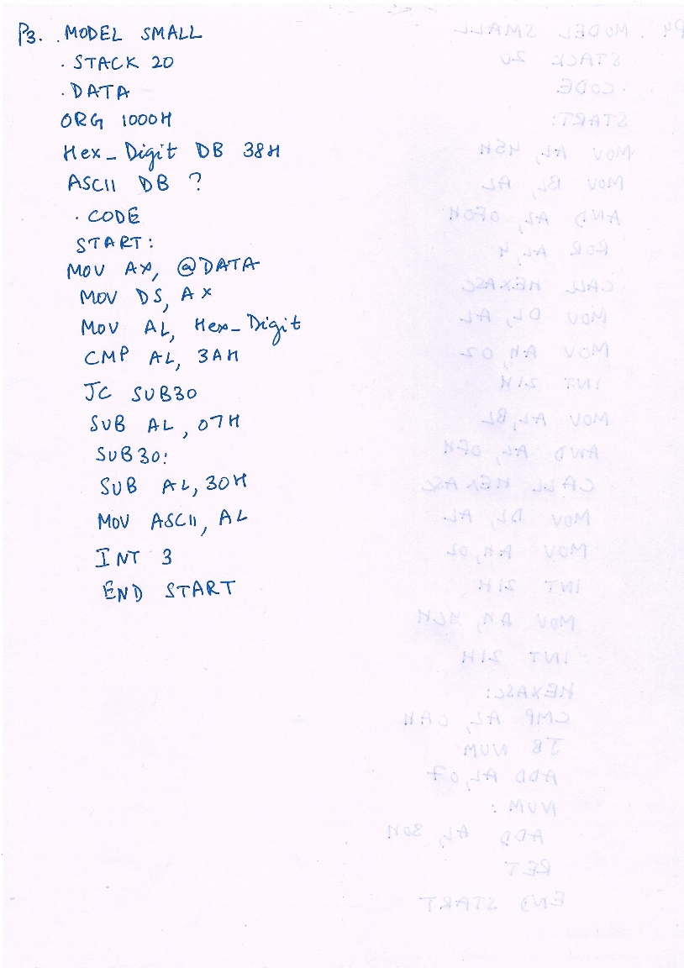

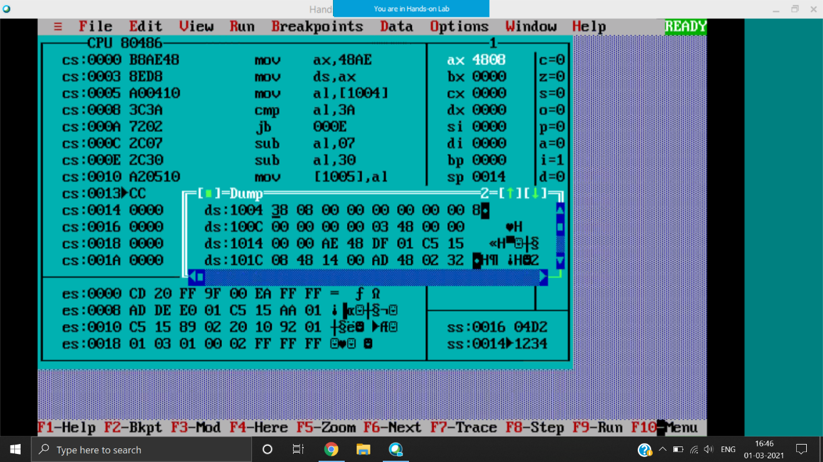

DS:1004H

Output given 08 at 1005

P4: Write a program to display the hexadecimal byte 45H on the screen using DOS interrupts. Previous program is HEXASC (HEX TO ASCII), refer for the HEXASC procedure.

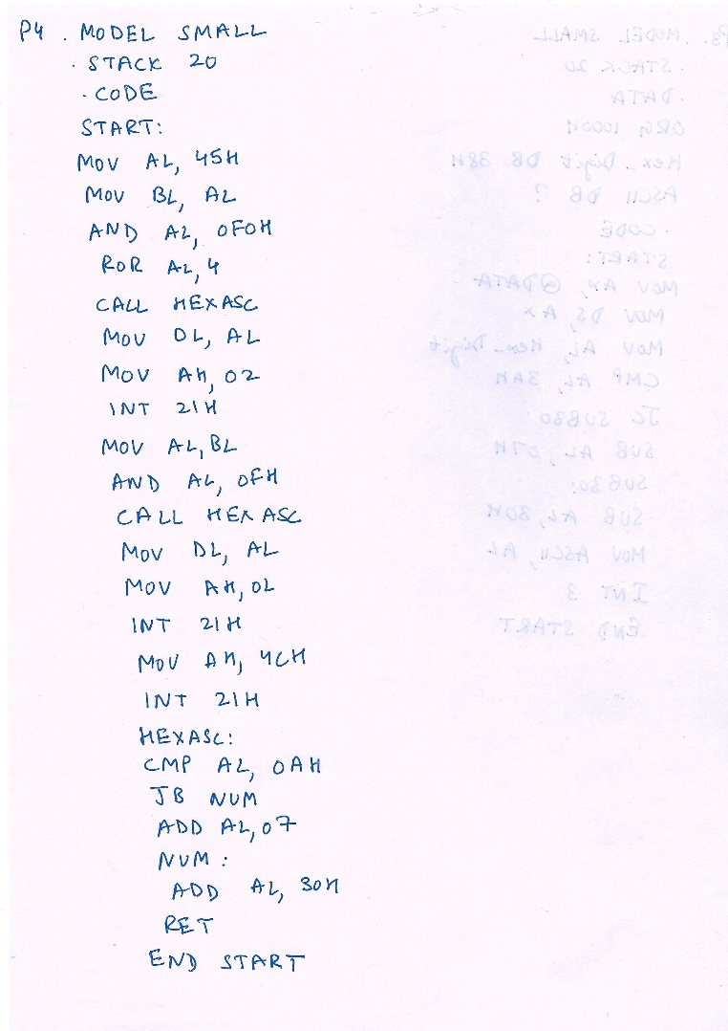

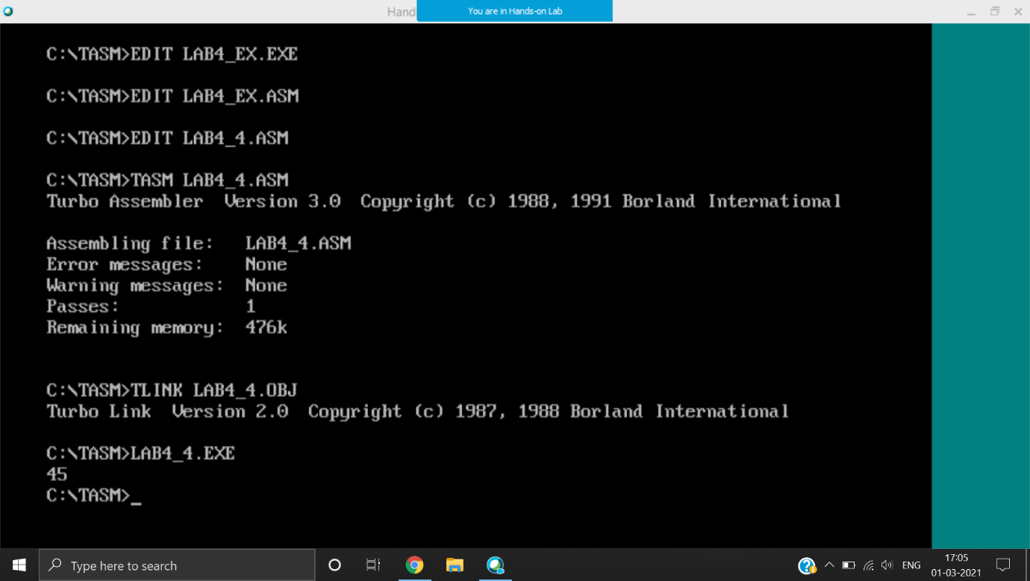

45 displayed on DOS windows

Ex 2: Write a program to accept a character from keyboard and display its ASCII equivalent value on the screen.

|  |  |
| --- | --- |
|  |  |

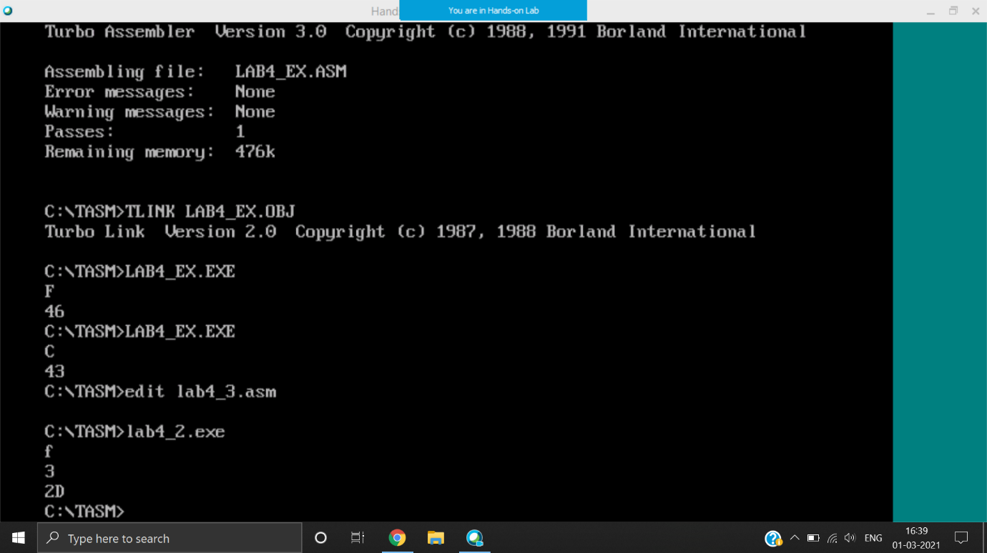

Displays the ASCII value of F ie 46 and C ie 43